Solution: Build a scrollable component

Overview
In this reading, you will review the solution code for the exercise.
The code block below outlines the outcome of the exercise in its entirety.

WelcomeScreen.js
import * as React from 'react';
import { ScrollView, Text } from 'react-native';

export default function WelcomeScreen() {
return (
<ScrollView indicatorStyle={"white"} style={{ flex: 1 }} showsVerticalScrollIndicator = {false}>
<Text
style={{
padding: 40,
fontSize: 50,
color: '#EDEFEE',
textAlign: 'center',
}}>
Welcome to Little Lemon
</Text>
<Text
style={{
fontSize: 38,
padding: 20,
marginVertical: 8,
color: '#EDEFEE',
textAlign: 'center',
}}>
Little Lemon is a charming neighborhood bistro that serves simple food
and classic cocktails in a lively but casual environment. We would love
to hear more about your experience with us!
</Text>
</ScrollView>
);
}

App.js
import LittleLemonHeader from './components/LittleLemonHeader';
import LittleLemonFooter from './components/LittleLemonFooter';
import WelcomeScreen from "./WelcomeScreen";

export default function App() {
return (
<>
<View
style={{
flex: 1,
backgroundColor: '#495E57',
}}>
<LittleLemonHeader />
<WelcomeScreen />
</View>
<View style={{ backgroundColor: '#495E57' }}>
<LittleLemonFooter />
</View>
</>
);
}

The font size on the Welcome screen is fairly large and needs to be scrollable. The code above produces the following output on the emulator with a scrollable screen:

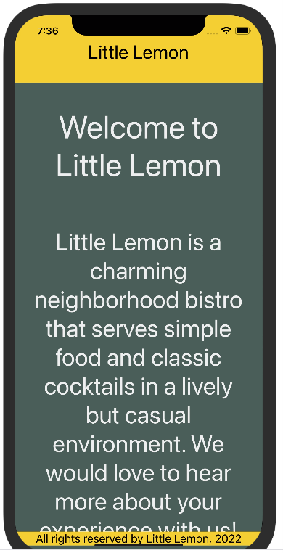

Procedure
Next, review the breakdown of the individual steps below.

Step 1: Enhance Welcome Screen to be Scrollable
Modify the Welcome Screen to use ScrollView component instead of the View component for the parent view.
export default function WelcomeScreen() {
return (
<ScrollView style={{ flex: 1 }}>
<Text
style={{
padding: 40,
fontSize: 50,
color: '#EDEFEE',
textAlign: 'center',
}}>
Welcome to Little Lemon
</Text>
<Text
style={{
fontSize: 38,
padding: 20,
marginVertical: 8,
color: '#EDEFEE',
textAlign: 'center',
}}>
Little Lemon is a charming neighborhood bistro that serves simple food
and classic cocktails in a lively but casual environment. We would love
to hear more about your experience with us!
</Text>
</ScrollView>
);
}

Step 2: Ensure that the scroll indicator is white in color
Pass the prop indicatorStyle to the ScrollView component and give it the value white. This will ensure that the scroll indicator is white in color.
<ScrollView indicatorStyle={"white"} style={{ flex: 1 }}>

...

